**ELECTRIC VEHICLE MARKET SEGMENTATION ANALYSIS**

Astik Alamprabhu Watambe

Github-<https://github.com/Asw13/Market-Segmentation-Analysis-of-EV>

1. **Introduction**

The electric vehicle (EV) market is undergoing a significant transformation globally, with India emerging as one of the key regions for future EV growth. With the government's push towards clean energy and the rise in consumer awareness about environmental sustainability, the adoption of electric vehicles in India is expected to accelerate in the coming years. However, the market is highly fragmented, with different states showing varying levels of readiness in terms of EV adoption, infrastructure development, and market potential.

As a team working under an EV startup, our objective is to identify the most promising market segments for 2-wheeler and 4-wheeler electric vehicles in India. Through a detailed analysis of EV sales data and the availability of charging stations across different states, we aim to devise a market entry strategy that focuses on high-potential regions. This report presents an in-depth analysis of the Indian EV market, leveraging segmentation techniques such as k-means clustering to group states based on their EV sales performance and infrastructure readiness. By doing so, we aim to provide actionable insights that can guide the startup in targeting the right segments for early growth and adoption.

The findings in this report will help the startup to strategically enter the market in regions where EV adoption is most likely to succeed, enabling a focused and data-driven approach to business expansion.

1. **Problem Statement and Fermi Estimation**

**Problem Statement:**

The electric vehicle (EV) startup faces the challenge of determining which states in India are most suited for early market entry, given the varying levels of infrastructure, sales potential, and consumer readiness across the country. The primary goal is to identify the most promising regions for launching 2-wheeler and 4-wheeler electric vehicles based on a combination of factors such as EV sales trends and the availability of charging stations. The startup needs a data-driven market entry strategy that segments the market and pinpoints states with the highest potential for rapid adoption of electric vehicles.

**Key Questions:**

1. Which states have the highest demand for electric vehicles?
2. How does the availability of EV infrastructure (charging stations) impact market readiness?
3. Which states can be categorized as high, moderate, and low potential for early EV adoption?
4. How can we use segmentation analysis to guide strategic decisions on market entry and resource allocation?

The solution to this problem requires careful segmentation of the market based on EV sales data and charging station availability, while also factoring in economic and demographic trends that may influence adoption.

**Fermi Estimation:**

To estimate the size and growth potential of the Indian EV market, we employ a **Fermi estimation** approach. This method allows us to make quick, back-of-the-envelope calculations using approximate data to gain insights into the market size and potential EV sales growth.

**Example of Fermi Estimation for 2-Wheeler EV Market:**

Based on this rough calculation, the 2-wheeler EV market in India could potentially reach around **17.15 million users** in the next 5 years. A similar estimation process can be applied for 4-wheelers and other vehicle categories.

These estimates help us to prioritize our focus on regions with the highest population density, urbanization rates, and existing EV adoption trends. By leveraging Fermi estimation, we can make educated guesses about market size and growth potential, which will inform our decision-making process in the absence of precise data for all variables. This also aligns with our strategy to segment the market based on both current and future potential for EV adoption.

1. **Data Sources and Collection**

To conduct a thorough analysis of the electric vehicle market in India, two primary data sources were used for extracting EV sales data and charging station information:

* 1. **EV Sales Data**:
  + **Source**: [Parivahan Portal](https://parivahan.gov.in/parivahan/)
  + **Details**: The data was extracted from the Parivahan Portal, which provides detailed information on electric vehicle registrations and sales across Indian states from 2019 to 2024. The data includes state-wise EV sales figures for different vehicle categories such as 2-wheelers, 3-wheelers, and 4-wheelers, allowing us to analyze growth trends over time.
  1. **Charging Station Data**:
  + **Source**: [Data.gov.in](https://www.data.gov.in/)
  + **Details**: The charging station data was obtained from Data.gov.in, which provides comprehensive information on the number of public charging stations available across various states in India. This data is crucial in understanding the infrastructure readiness of different regions to support EV adoption.

These datasets provide a strong foundation for segmenting the market and identifying the potential for early market entry based on sales trends and infrastructure development. In addition to these sources, any further data collection will involve supplementary market research and external reports to enhance the accuracy of our analysis

**Data Pre-processing**

To ensure the data was suitable for analysis, the following steps were taken:

* **Checking Diminutions of Data**
* **Handling Missing Values**: Missing values in the datasets were replaced with 0 rather than being dropped to avoid losing valuable information.

1. **Segment Extraction**
   1. **Data Visualization**

Data visualization plays a critical role in understanding the market trends and patterns that drive electric vehicle (EV) adoption across India. In this project, various visualization techniques have been employed to derive insights from the datasets collected, with a focus on understanding EV sales and infrastructure distribution across different states.

* + 1. **Pie and Bar Plots for Charging Stations**

• **Visualization**: A pie plot and bar plot were used to visualize the number of charging stations available across Indian states in 2024

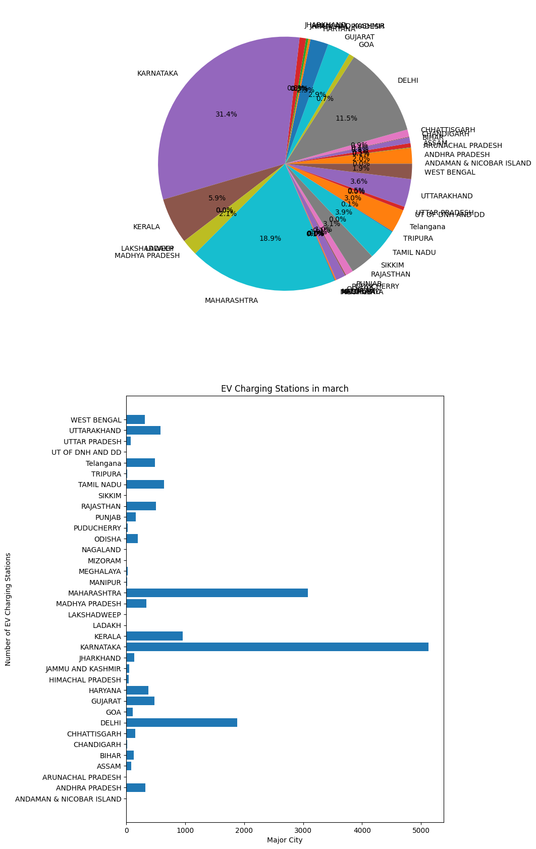

• **Key Insight**: States such as **Maharashtra, Karnataka, Kerala, and Delhi** have the highest number of charging stations, accounting for a significant portion of the country’s EV infrastructure. This indicates that these states are likely to support higher EV adoption due to better charging facilities, making them ideal for early market entry.

* + 1. **Pie and Bar Plots for 2-Wheeler EV Sales**

• **Visualization**: Pie and bar plots were generated for 2-wheeler EV sales from 2019 to 2024 to show market growth and state-wise contributions.

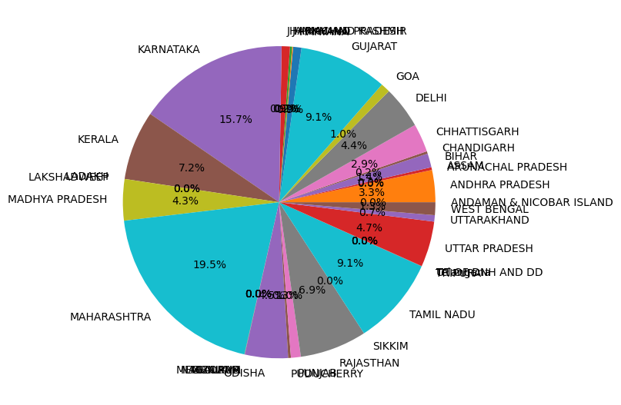

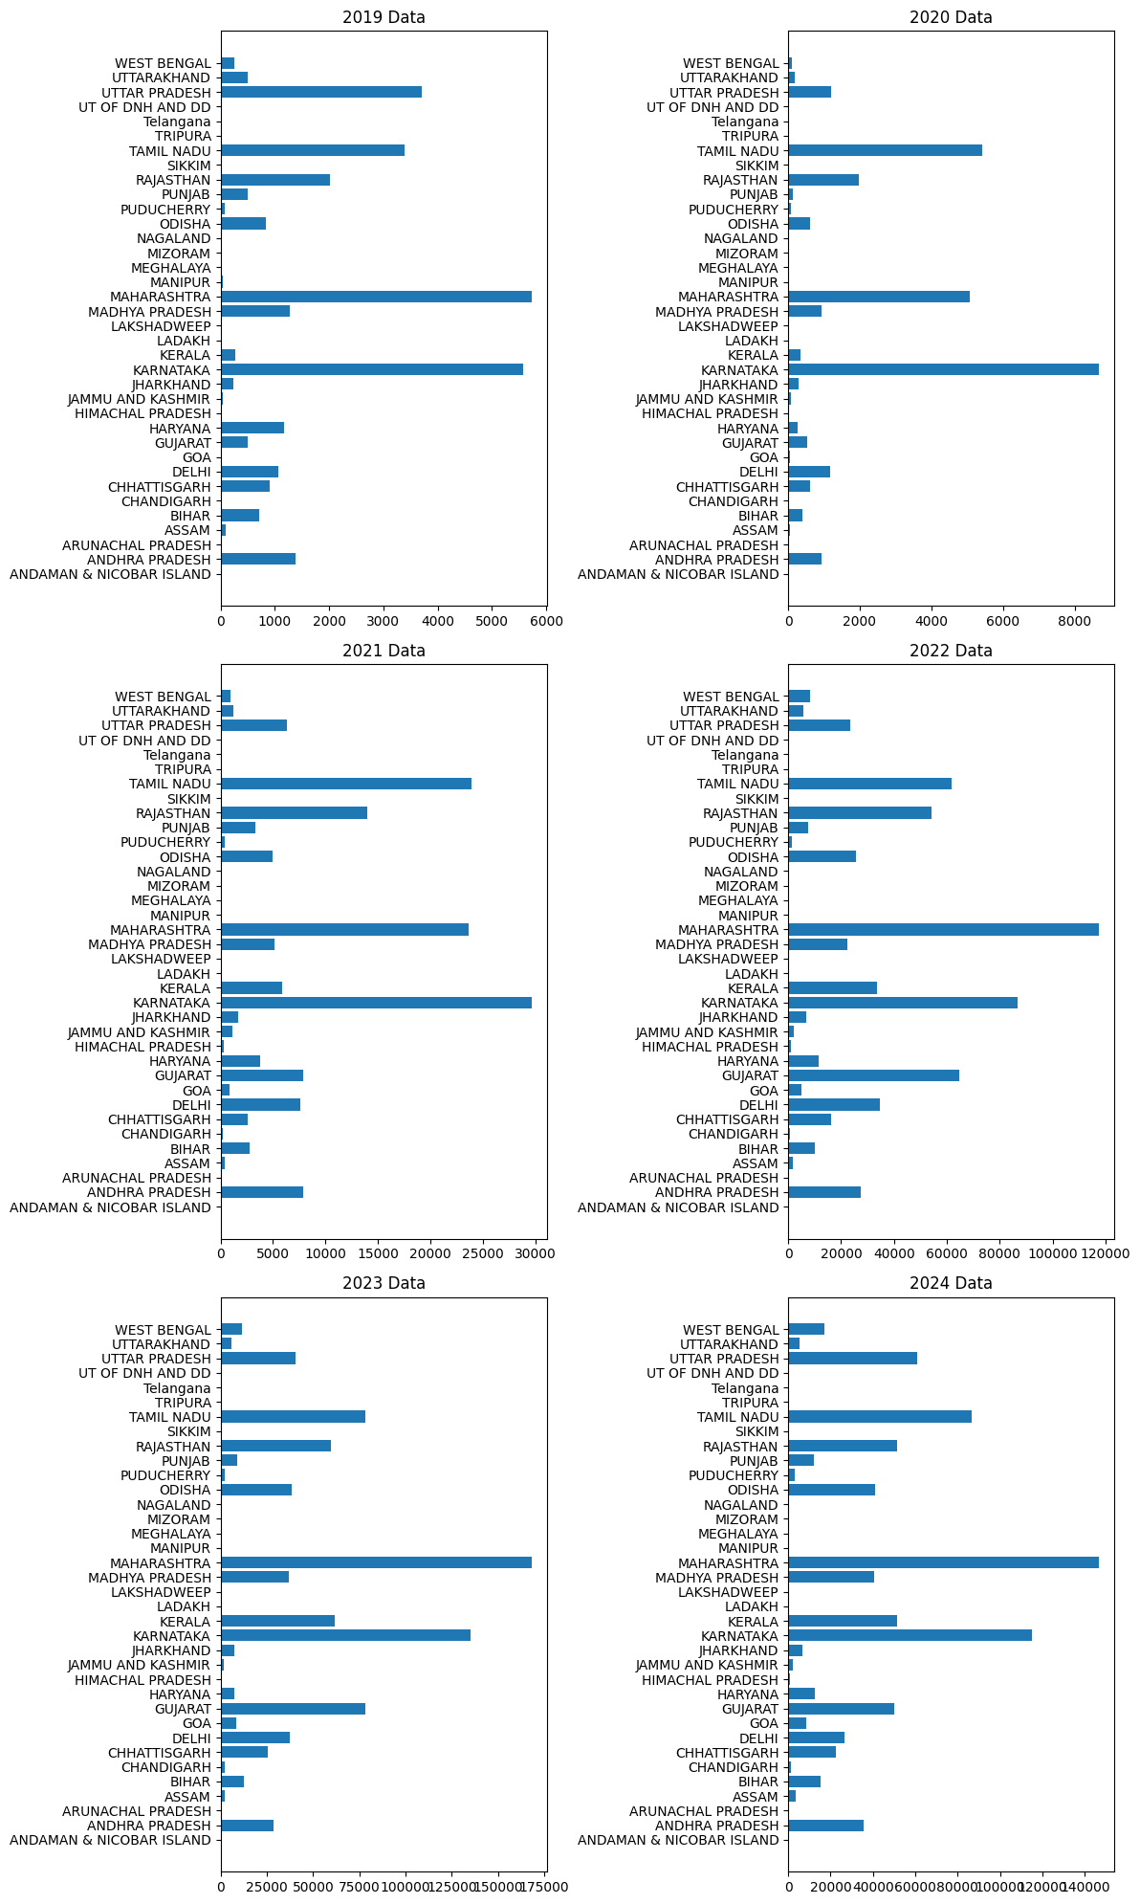

• **Key Insight**: The 2-wheeler EV market has grown by nearly **2000%** over the five-year period. **Maharashtra, Karnataka, Gujarat, and Tamil Nadu** account for more than 50% of the market share in 2024, indicating strong demand in these states.

* + 1. **Pie and Bar Plots for 3-Wheeler EV Sales**

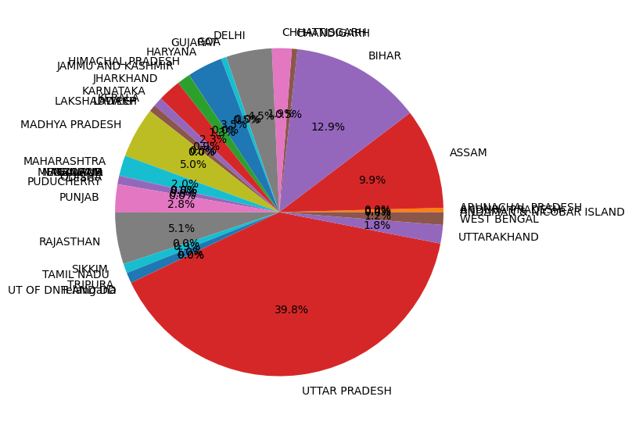• **Visualization**: A similar set of pie and bar plots were used for 3-wheeler EV sales from 2019 to 2024.

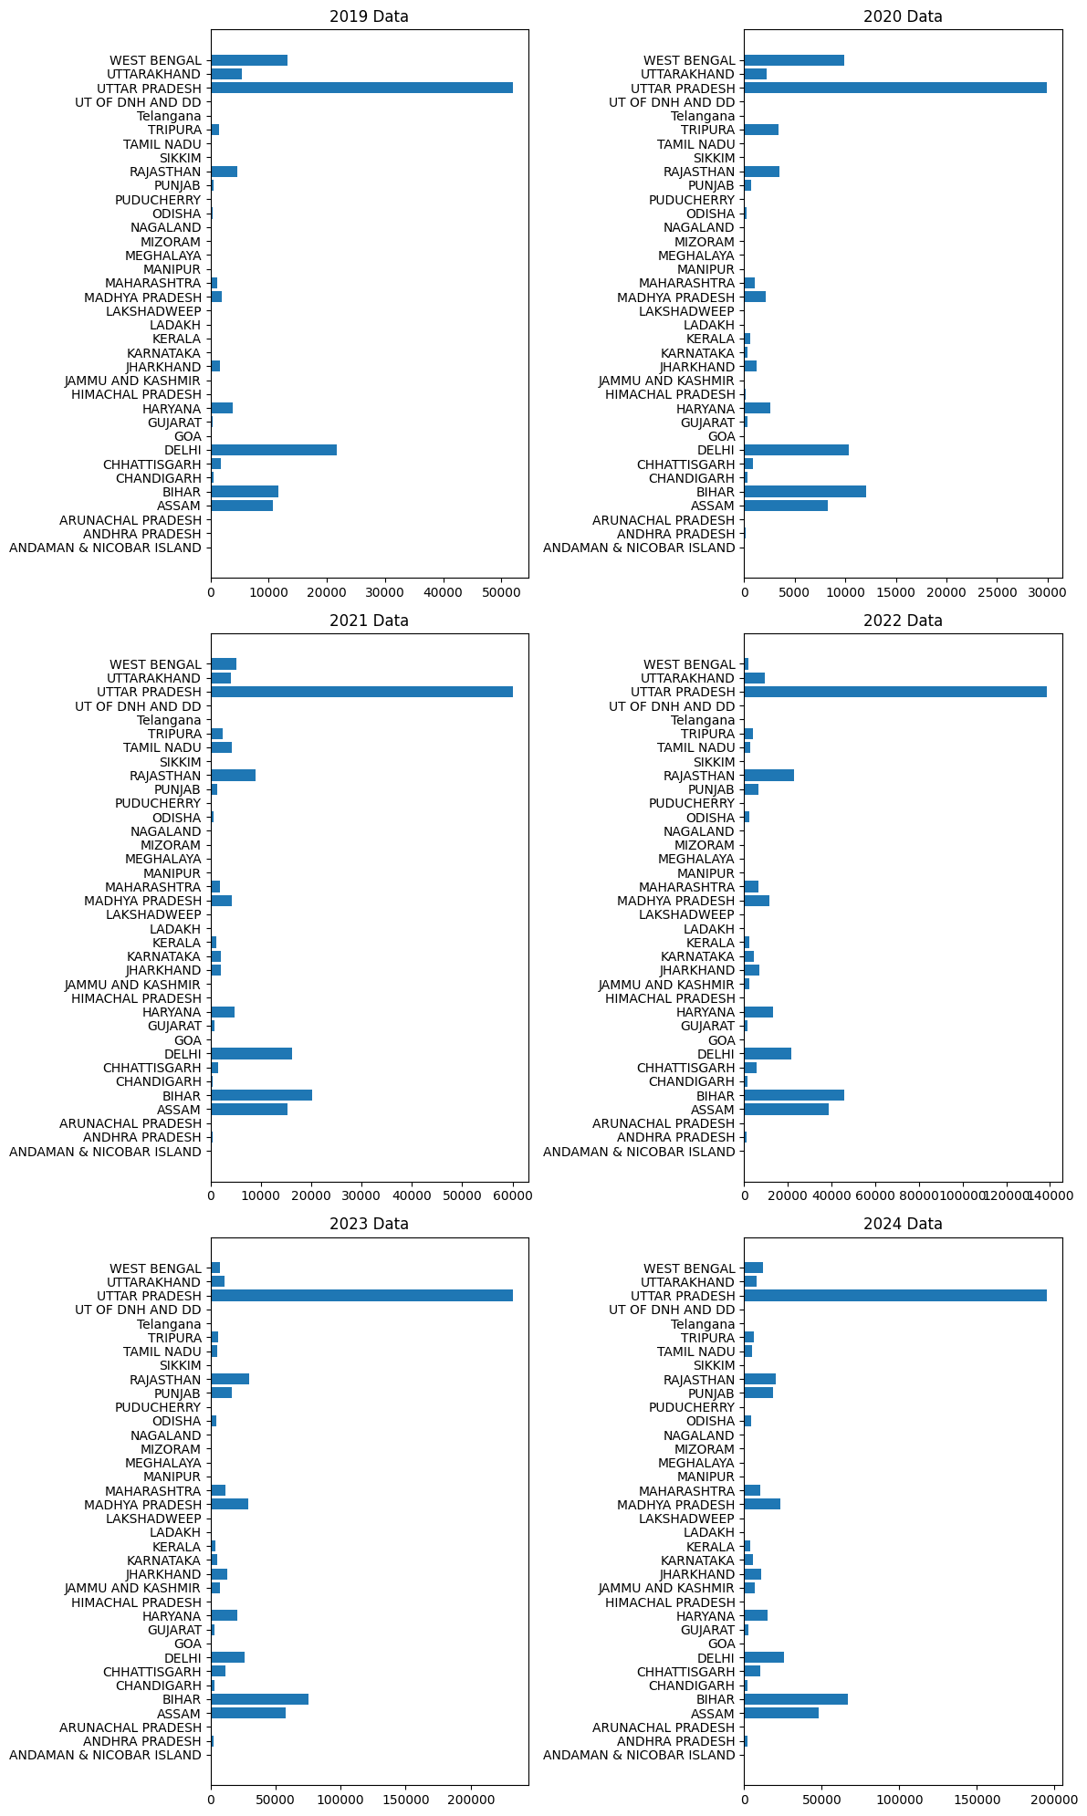

• **Key Insight**: The 3-wheeler EV market has grown by **500%**. States like **Uttar Pradesh, Bihar, and Assam** contribute over 60% of the market, with Uttar Pradesh consistently being the highest contributor. These states represent significant opportunities for 3-wheeler EV manufacturers.

* + 1. **Pie and Bar Plots for 4-Wheeler EV Sales**

• **Visualization**: Pie and bar plots were generated for 4-wheeler EV sales over the same period.

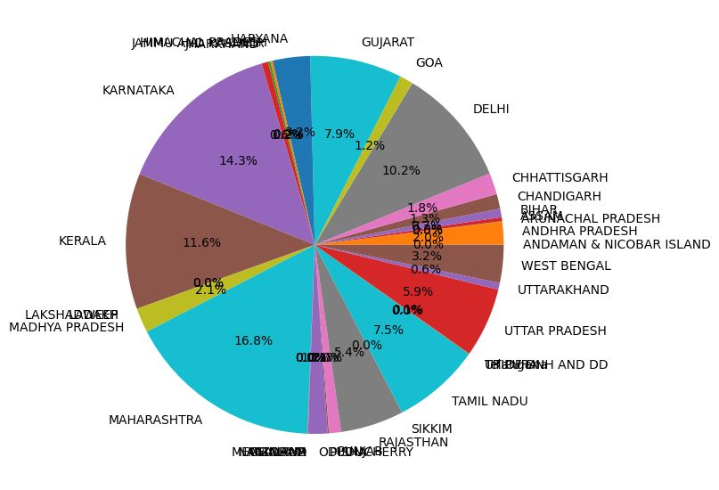

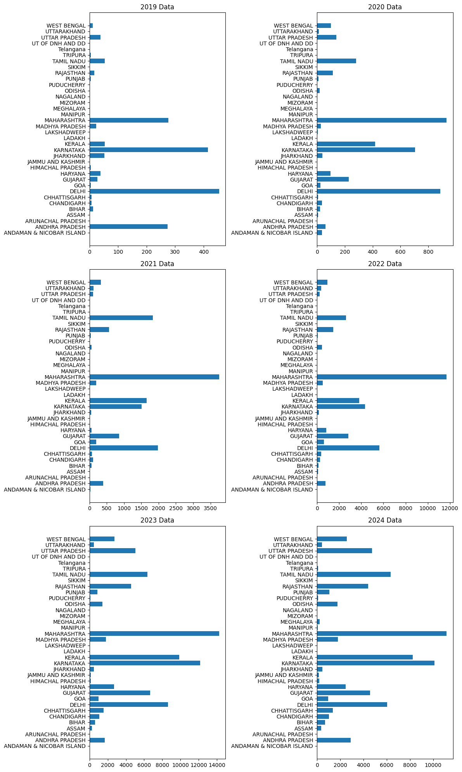

• **Key Insight**: The 4-wheeler EV market has grown by **2800%**, with **Maharashtra, Karnataka, Kerala, and Delhi** contributing more than 50% of the market. Notably, **Uttar Pradesh** has shown increasing contributions in recent years, signaling a growing demand in this state.

* + 1. **Transposed Line Plots for Year-wise EV Sales**

**Visualization**: Transposed line plots were used to track year-wise sales growth for the top 10 states.

* 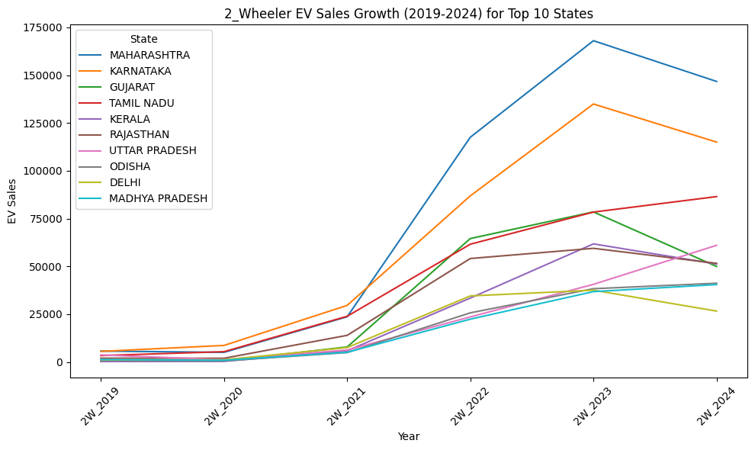**2-Wheeler EV Sales**: The plot highlights that Maharashtra and Karnataka experienced the highest sales growth between 2021 and 2024, indicating rapid adoption during these years.
* **4-Wheeler EV Sales**: Similar trends were observed for 4-wheelers, with Maharashtra and Karnataka showing the strongest growth over the last three years.

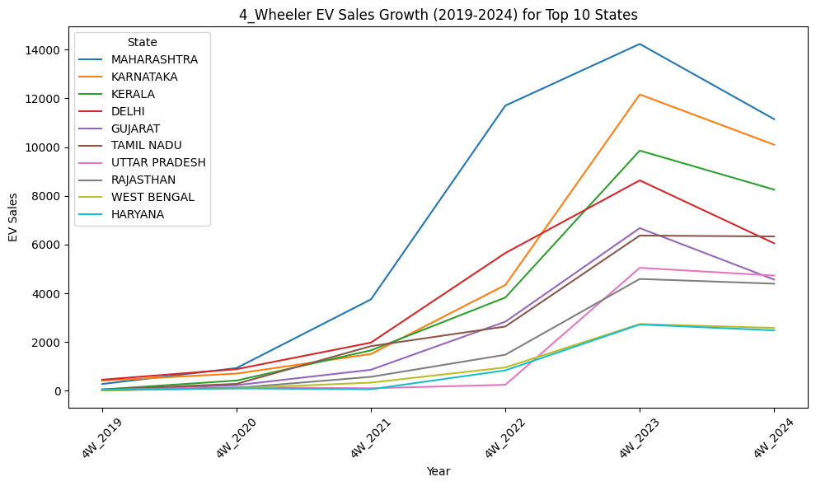

* + 1. **Correlation Heat Maps**

• **Visualization**: Correlation heat maps were used to analyze the relationship between EV sales (both 2-wheeler and 4-wheeler) and the number of charging stations across different states.

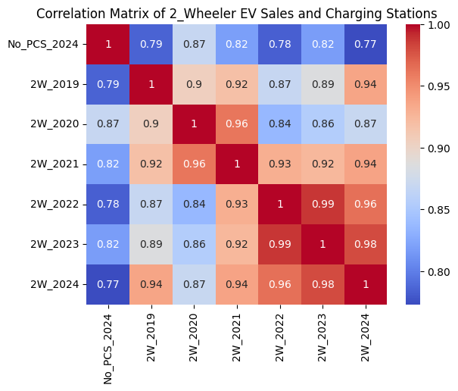

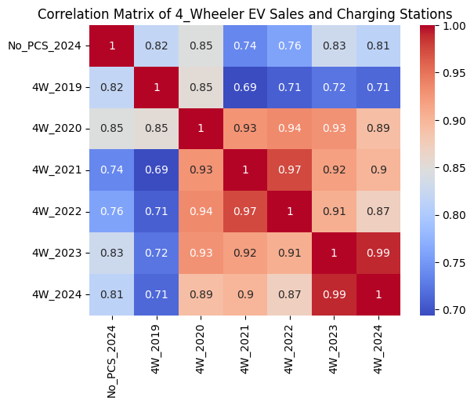• **Key Insight**: A strong positive correlation was observed, ranging between **0.78 and 0.87** for 2-wheelers and **0.78 and 0.85** for 4-wheelers. This indicates that states with more charging stations tend to have higher EV sales, confirming the importance of infrastructure in driving EV adoption.

* 1. **Clustering Analysis**

To segment the Indian electric vehicle (EV) market based on sales trends and infrastructure readiness, we employed **k-means clustering**. This unsupervised learning technique allows us to group states with similar characteristics into clusters, helping identify potential regions for market entry. Clustering helps the startup make data-driven decisions on where to focus its resources for the best return on investment.

**Data Preparation**

Before performing clustering analysis, the data was pre-processed and normalized:

**Variables Used**: EV sales data (2-wheeler and 4-wheeler) from 2019-2024, and the number of charging stations in each state.

**Scaling**: Since the variables were on different scales (charging stations and sales numbers), data scaling was applied to standardize the values.

**Principal Component Analysis (PCA)**: PCA was also considered to reduce the dimensionality of the data and capture the most important variance before clustering. However, after review, we retained the original features, as the variables themselves were meaningful for segmentation.

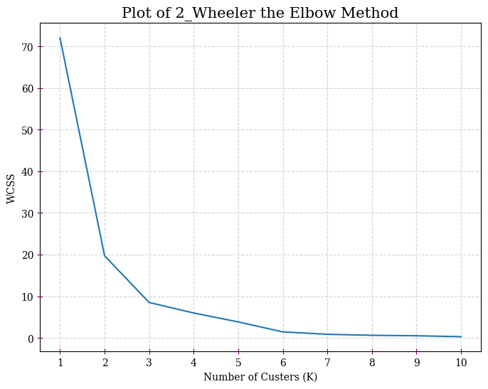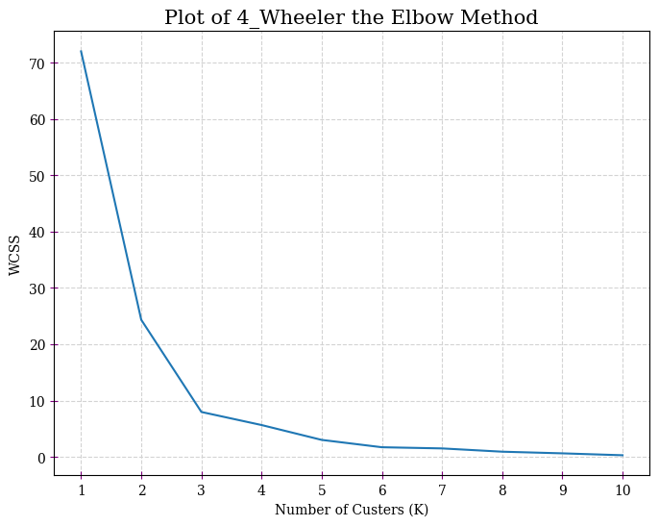

The k-means algorithm was applied to the dataset to divide the states into clusters based on their EV sales and charging infrastructure. Several runs were performed with different values of k (number of clusters), and after analyzing the elbow curve, we settled on k = 3 as the optimal number of clusters.

**Scatter Plot**: A scatter plot of EV sales (on the x-axis) and the number of charging stations (on the y-axis) was created, with the clusters color-coded. This clearly showed the separation of states into high, moderate, and low-potential segments.

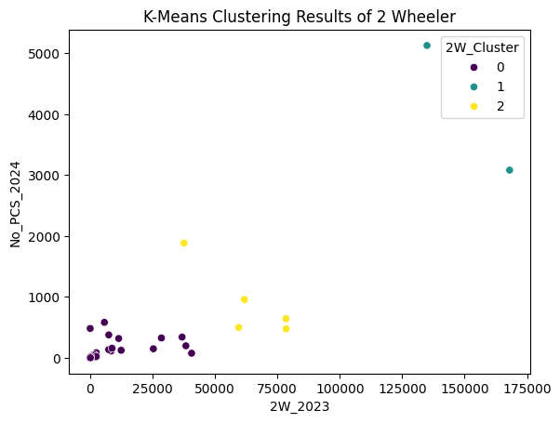

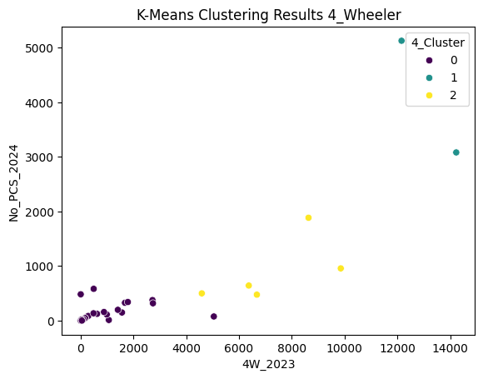

**High Potential Segment**

* + 1. **States**: Karnataka, Maharashtra.
    2. **Characteristics**: High EV sales and well-developed charging infrastructure.
    3. **Strategy**: Focus on expanding EV offerings and enhancing user experience to sustain growth.

**Moderate Potential Segment**

* + 1. **States**: Delhi, Gujarat, Kerala, Rajasthan, Tamil Nadu.
    2. **Characteristics**: Moderate EV sales and developing infrastructure.
    3. **Strategy**: These regions present an opportunity for strategic investments in charging stations and marketing campaigns to increase EV adoption.

**Low Potential Segment**

* + 1. **States**: 29 remaining states.
    2. **Characteristics**: Low EV sales and minimal infrastructure.
    3. **Strategy**: These states may require government support, partnerships, or a long-term strategy focusing on improving infrastructure and creating awareness.

1. **Conclusion**

This analysis provides valuable insights into the segmentation of the Indian EV market. The identified high-potential states, such as Karnataka and Maharashtra, offer the greatest opportunities for immediate market penetration, while moderate potential states provide a growing market. The low-potential segment, with low sales and minimal infrastructure, may not be viable for short-term focus but could be included in a long-term growth strategy.

**Recommendations for the Startup:**

* **High-Potential States**: Focus on vehicle sales and enhancing charging infrastructure.
* **Moderate-Potential States**: Prioritize marketing efforts and building infrastructure.
* **Low-Potential States**: Leverage government incentives and raise consumer awareness.